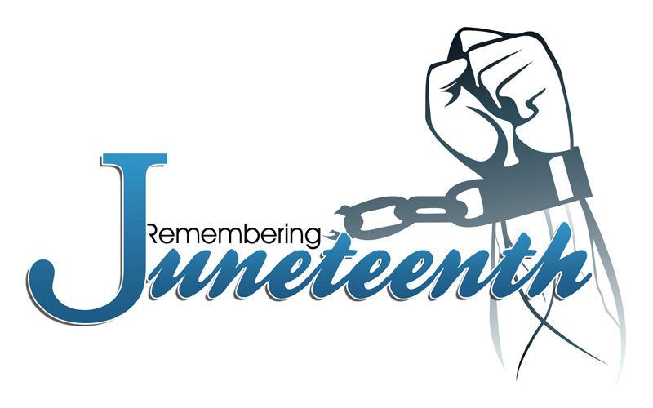

Utah Juneteenth Festival June 17-19, 2016

**“Renewing Our Strength…Mind, Body, Spirit”**

The Utah Juneteenth Committee is pleased to announce the Mr. and Ms. Juneteenth Scholarship Pageant. In the spirit of Nguzo Saba, the seven principles of Kwanzaa, we celebrate our African/African American youth.

Eligibility Criteria: African/African American student in grade 11-12 during the 2015-2016 school year.

Process: Fill out and return application form, along with typed essay and picture. **Deadline June 1, 2016**. Return via US mail to Project Success Coalition, P.O. Box 151003, Ogden, UT 84415 or via email to brenda_burrell@msn.com.

Recognition: All applicants must participate at the Juneteenth Scholarship Pageant on Friday evening, June 17, 2016 where winners will be selected during the State of Black Utah Roundtable Discussion. Participants MUST be present to claim any award. All participants will be recognized at the Juneteenth Festival on June 18, 2016. Both events will be held at Weber State University.

Awards: All applicants will receive a certificate of achievement and gift card. Mr. and Ms. Juneteenth will receive a scholarship award and crown and have the honor of representing Juneteenth all year long. Financial Support for this pageant is provided by Mr. and Mrs. Daryl Davis.

*Juneteenth is the oldest nationally celebrated commemoration of the ending of slavery in the United States. From its Galveston, Texas origin in 1865, the observance of June 19th as the African American Emancipation Day has spread across the United States and beyond. www.juneteenth.com*

* *Umoja (Unity): To strive for and to maintain unity in the family, community, nation, and race.*
* *Kujichagulia (Self-Determination): To define ourselves, name ourselves, create for ourselves, and speak for ourselves.*
* *Ujima (Collective Work and Responsibility): To build and maintain our community together and make our brothers' and sisters' problems our problems, and to solve them together.*
* [*Ujamaa*](http://en.wikipedia.org/wiki/Ujamaa)*(*[*Cooperative Economics*](http://en.wikipedia.org/wiki/Cooperative_economics)*): To build and maintain our own stores, shops, and other businesses and to profit from them together.*
* *Nia (Purpose): To make our collective vocation the building and developing of our community in order to restore our people to their traditional greatness.*
* *Kuumba (Creativity): To do always as much as we can, in the way we can, in order to leave our community more beautiful and beneficial than we inherited it.*
* *Imani (Faith): To believe with all our hearts in our people, our parents, our teachers, our leaders, and the righteousness and victory of our struggle.*